- A student thinks that the formula for the current I in a conductor of length l is

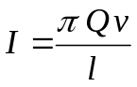
where Q is the charge on each charge carrier and v is their average drift velocity.

(a) Show whether or not the equation is homogeneous with respect to units.

[3]

(b) Suggest why an equation which is homogeneous with respect to units may not be correct.
Some constants/numerical values have no units or Experimentally not verified
>> Constants may have units ??
…………………………………………………………………………………[1]

(c) Another equation for the current I is given by the formula

I = nAQv

where A is the cross-sectional area of the conductor.
Suggest a physical quantity that may be represented by n.
(Number of charge carrier) per unit volume [1]

(d) Voltage is defined as energy per unit charge and the unit is volt. Express the volt in terms of base units only.

No unit in fraction

Base units = kgm²s⁻³A⁻¹ [2]
- A cyclist accelerates steadily from rest on a 1500 m downhill stretch of road, reaching a top speed of 22.0 m s⁻¹ before free wheeling on a level road with uniform deceleration to a halt 192 seconds after starting.

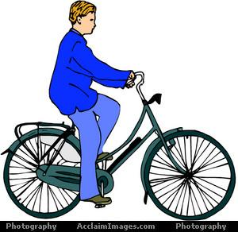
1500 m
θ
(not drawn to scale)
  - Calculate the time taken by the cyclist to reach the top speed.

Time = 136 s [2]

  - Sketch a speed-time graph to represent the journey. Indicate any relevant values on both axes of the graph.

[2]
v / m s⁻¹
t / s
0

  - Calculate the deceleration of the cyclist when he is moving on the level road.

Deceleration = 0.395 ms⁻² [2]

  - Explain how the angle of incline of the downhill road, θ affects the top speed that the cyclist attains.
Angle increases greater height when moving down, higher GPE, - 1
when all GPE>> KE, Final speed at the bottom increases - 1 OR
Angle increases a=gsinθ increases - 1
a=dv/dt, v increases - 1
…………………………………………………………………………………[2]

- Fig. 3.1 shows a pen, drawn full (actual) size, without its cap. The pen has a mass of 11 g and balances on a pivot 80 mm from the end A.
pivot
A
Fig. 3.1
- Calculate the weight of the pen.

Weight = 0.108 N[1]

- The cap is now put on the pen. The cap has a weight W which acts at the point shown. The pen together with its cap is then balanced as shown in Fig. 3.2, which is also drawn full (actual) size. (You may use the diagram, where necessary measuring distances on it with a ruler to answer the following questions.)
pivot
A
W
Fig. 3.2

- Add to Fig. 3.2 a labelled arrow to represent the weight of the pen without its cap.
[1]
- By taking moments about the pivot, determine the weight W of the cap.
Taking moments about the pivot,
W_{body} x d₁ = W_{cap} x d₂

OR
Taking moments about the point A,

Weight of cap = 0.0284 N[3]
- In addition to the two weights, a third force acts on the pen when balanced as in Fig. 3.2.
(i) State where this force acts and give its direction.
......................................................................................................................[1]
(ii) Calculate its magnitude.

Magnitude = ........................N[1]

- (a) In an experiment, a steel wire is stretched elastically. The following data are obtained:

Original length : 1.5 m
Diameter : 0.3 mm
Force applied : 10 N
Young modulus : 2.0 x 10¹¹ Pa

(i) Calculate the extension of the wire when the force is applied.

Calculate area from diameter
Convert mm to m
E=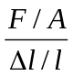

Extension = 1.1 x 10⁻³ m [3]

(ii) Calculate the elastic potential energy stored in the steel wire.

Assumption :
W= ½ Fx

>> Why not W=Fx ??

Potential energy= 5.5 x 10⁻³ J [1]
(b) Explain the meaning of the following words as used to describe large scale properties of materials.

(i) Ductile
performs elastic deformation and then large plastic deformation after elastic limit is exceeded.
………………………………………………………………………………[1]

(ii) Brittle
performs elastic deformation only then snap
…………………………………………………………………………[1]

(iii) Rigid
Will not extend easily & higher Young modulus OR
Shows little or no change in shape when a force is exerted on it.
………………………………………………………………………………[1]

5 (a) Explain what is meant by the superposition of waves.
When two waves meet at the same point
the resultant displacement is the vector sum of the individual displacement of waves
….………………………………………………………………………………[2]

(b) Distinguish between constructive and destructive interference.
constructive interference occurs when two waves meet in phase, build up a max amplitude
destructive interference occurs when two waves meet 180º out of phase/ antiphase, build up a min /zero amplitude
….………………………………………………………………………………[3]

(c) A diffraction grating with 250 lines per millimetre is placed in front of the monochromatic source of red light. A screen placed 200 cm beyond the grating has red images measured at certain positions on a scale on the screen as shown in Fig. 5.1.
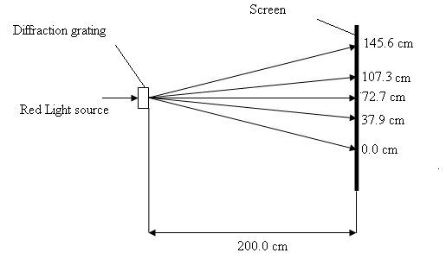

Fig. 5.1

Use the first order spectrum to deduce a value for the wavelength of the red light

Average distance between 1st order from the centre
tan θ = / 200
d = 1/250 mm = ….. x10⁻³

Wavelength =6.84x10⁻⁷m[3]

6 (a) What is meant by the term electric field strength?
……………………………………………………………………………………
….………………………………………………………………………………[2]

(b) A proton is moved in a vacuum by a uniform electric field of 2.7 x 10⁵ Vm⁻¹ from A to B, a distance of 0.0078 m as shown in Fig. 6.1.

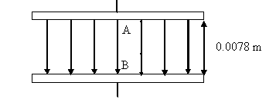

Fig. 6.1

(i) How much work is done by the field on the proton?

W= Fs = Eq s

Work= 3.37 x 10⁻¹⁶ J[2]

(ii) What is the gain in the kinetic energy of the proton?

W = gain in KE

Gain in KE = 3.37 x 10⁻¹⁶ J[1]

(iii) Calculate the difference in potential between A and B. State whether A or B is at the higher potential.

E= V/d

p.d. = 2110V
higher potential= A [3]

7. A car battery has an e.m.f. of 12.0 V. When a car is started, the battery supplies a current of 105 A to the starter motor. The terminal potential difference between the battery terminal drops at this time to 10.8 V due to the internal resistance of the battery.

Motor
E

Fig. 7.1

- Explain briefly what is meant by an e.m.f. of 12.0 V.
12J of energy of source is converted from other forms of energy to electrical energy when 1 coulomb of charge moves around the circuit.
….………………………………………………………………………………[2]

- Calculate the internal resistance of the battery.

Internal resistance =………….…0.0114……… Ω [2]
- The manufacturer warns against short-circuiting the battery.
  - Calculate the current which would flow if the terminals were to be short-circuited.

Current =…………1050.…………A [2]

  - Explain briefly why the manufacturer provides this warning.
Short circuit and damage the battery (NOT motor)
……………………………………………………………………………[1]

- When completely discharged, the battery can be fully recharged by a current of 2.5 A supplied for 20 hours.
  - How much charge is stored by the battery?

charge = 1.8 x 10⁵C [2]

  - For how long could the motor be operated on a fully-charged battery? Assume that the motor could be operated continuously.

Time =……..28.6……minutes [2]
8. (a) State two differences between α-particles and γ-rays.
……………………………………………………………………………………
……………………………………………………………………………………
……………………………………………………………………………………
….………………………………………………………………………………[2]

(b) Francium-222 (Fr) with 135 neutrons decays and produces Radium (Ra-222) and a beta particle. Write down the nuclear equation to show the decay.

……………………. → …………………………………. [2]

